**Git Lab Assignment 1:**

**1.Create a local git repo with the name "MyRepo".**

To create a new repo, you'll use the “git init” command.

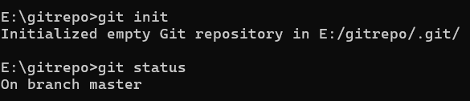

**2. create one .txt file, five .c files and five .java files in the working area**

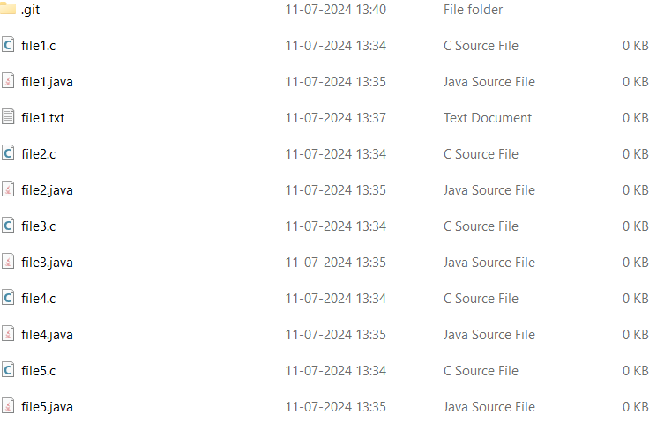

**3. Verify the git status**

To verify the git status use the “git status” command

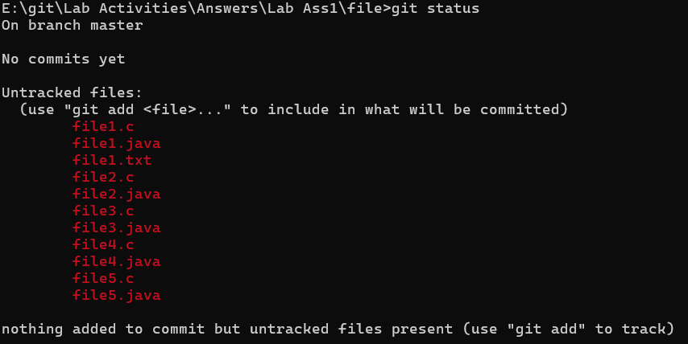

**4. Add only the .txt into the staging area**

**5. verify the git status**

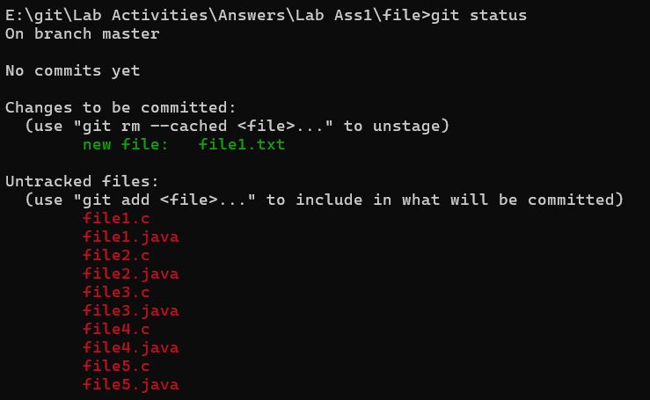

**6. Make a commit with the name "TXT Commit"**

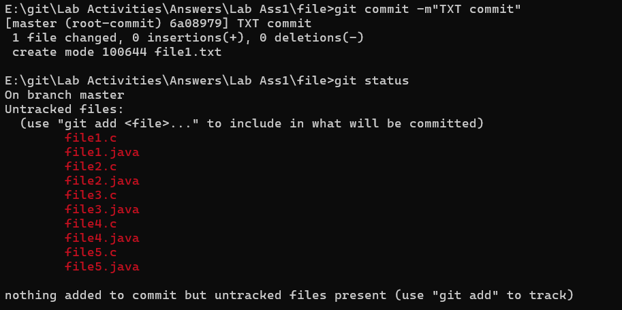

**7. Add all .c files into the staging area**



**8. verify the git status**

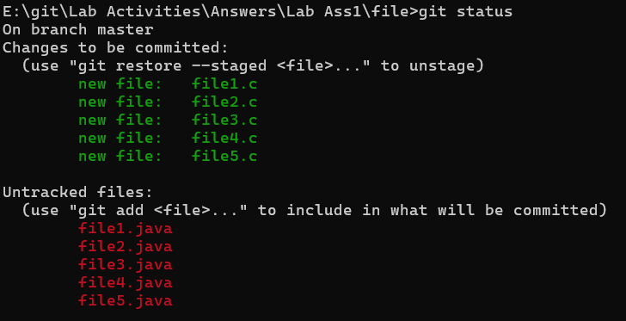

**9. Make a commit with the name "C Commit"**

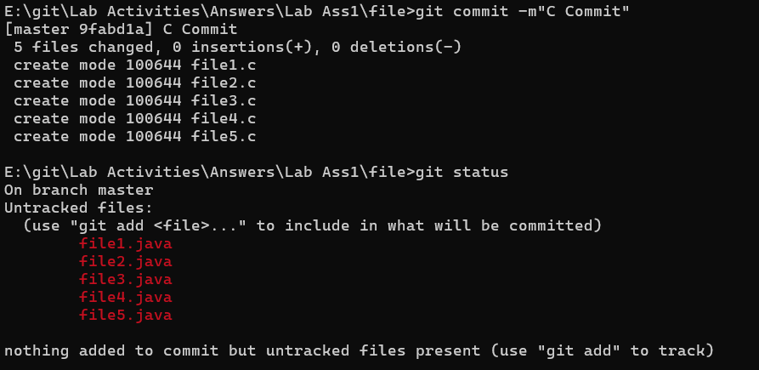

**10. Add all .java files into the staging area**



**11. verify the git status**

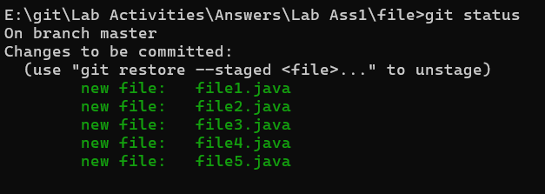

**12. Make a commit with the name "Java Commit"**

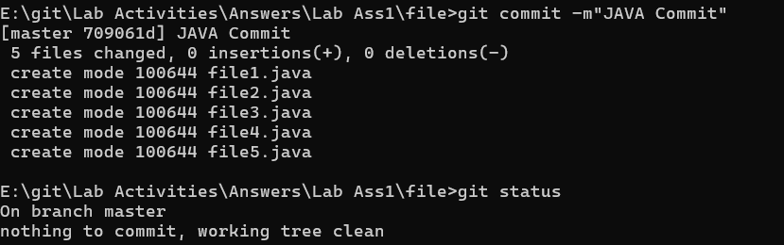

**13. Delete all .java files from working area**

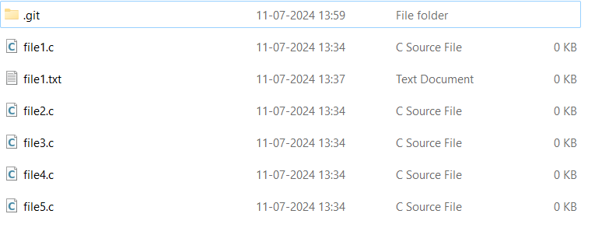

**14. Now see the status**

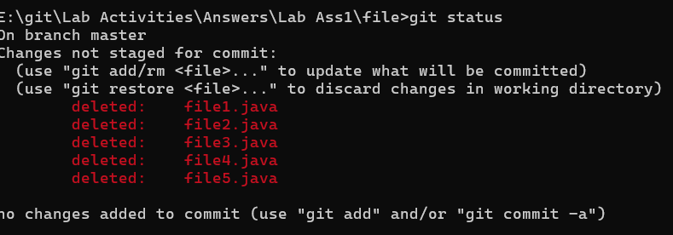

**15. add the changes into the staging area**

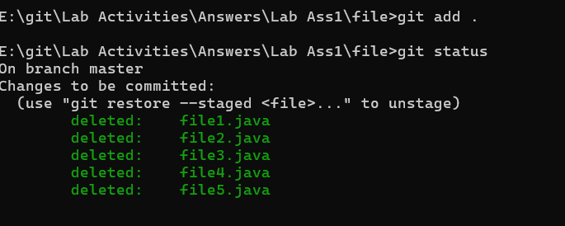

**16. Make a commit with the name "Delete Java Commit"**

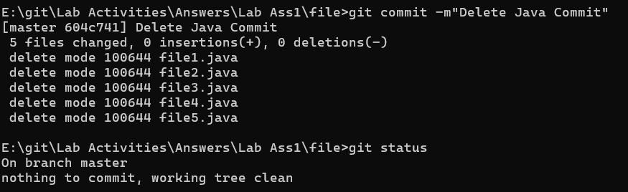

**17. display all commit details**

